Lesson 16: OPTIONAL How can we market our designs to our potential investors?

Previous Lesson | This was the last lesson of the formal unit. We evaluated other engineers’ design solutions to protect cheerleaders from concussions in collisions using the science and engineering ideas we have figured out over the course of the unit. We designed our own solution and argued how it takes into consideration the criteria, constraints, and trade-offs in the proposed solution. We revisited the DQB to take stock of the questions we have answered.
This Lesson  Putting Pieces Together  4 days   | 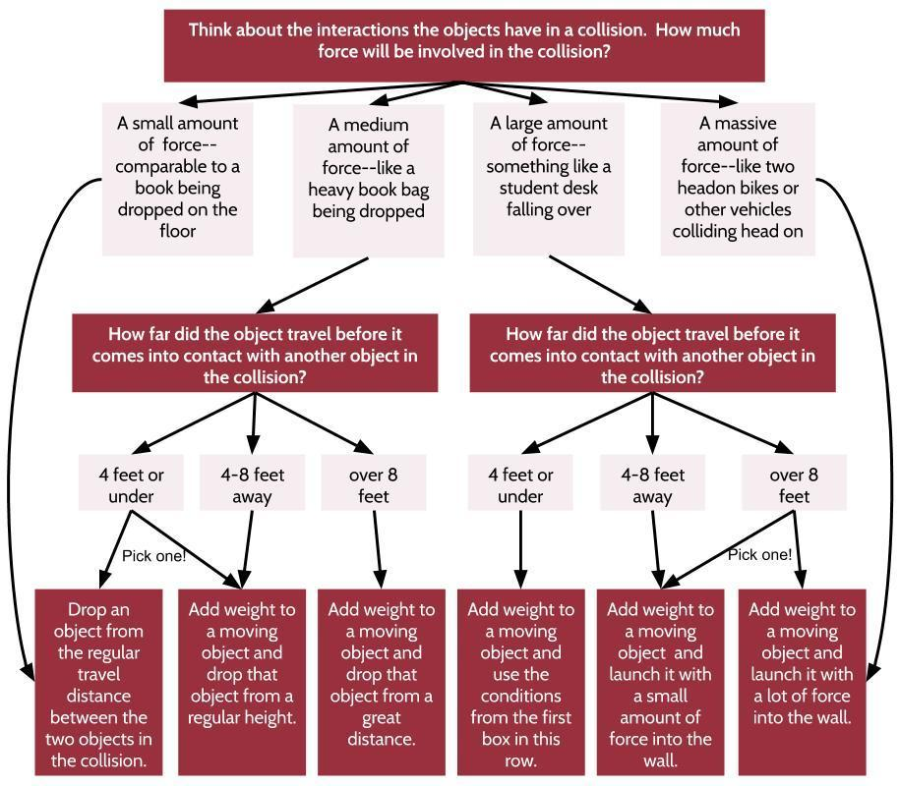 | This is an optional extension lesson. We develop a presentation to share with potential investors about the merits of our design. We have the option to create a scale prototype and test our designs. We have additional options to add visual aids to our presentations. We present our design ideas to investors.
Next Lesson | There is no next lesson.

BUILDING TOWARD NGSS  MS-PS2-1, MS-PS2-2, MS-PS3-1, MS-ETS1-2, MS-ETS1-3, MS-LS1-8   | What students will do  16.A Communicate and present information orally about the proposed performance of a protective device, explaining how specific structures and materials have been manipulated to reduce peak forces in a collision.  What students will figure out  - Investors care about the considerations of stakeholders.  - As a designer, information has to be presented in a clear, relevant, and engaging way that allows investors to see that all stakeholder considerations have been taken into account.

Lesson 16 • Learning Plan Snapshot
Part | Duration |  | Summary | Slide | Materials
1 | 5 min |  | INTRODUCE DESIGN PITCH PRESENTATION  Discuss what investors would want to know about designs and give a presentation overview. | A-B
2 | 15 min |  | DISCUSS PRESENTATION OPTIONS  Go over project presentation options and select individual presentation methods. |  | Presentation Format Options, Outlining an Investor Pitch Presentation, Final Design Proposal

End of day 1
3 | 135 min |  | CREATE PRESENTATIONS  Create design pitch presentations to be shared with investors. |  | Presentation Format Options, Outlining an Investor Pitch Presentation

End of day 2

Lesson 16 • Materials List
 | per student | per group | per class
Lesson materials | - Presentation Format Options  - Outlining an Investor Pitch Presentation  - Final Design Proposal

Materials preparation (15-45 minutes)

Review teacher guide, slides, and teacher references or keys (if applicable).

Make copies of handouts and ensure sufficient copies of student references, readings, and procedures are available.

- The preparation for this lesson will vary based on time available and student project choice.
- The scale model optional activity will require time to print handout Creating a Scale Model.
- The creation of a prototype for testing purposes will require time to print handout Determining Your Prototype Testing Conditions and prepare a testing area, which will vary based upon the type of object a student is protecting and school testing conditions (see Determining Your Prototype Testing Conditions to review what testing conditions are recommended to students, depending on device).
- The additional visual aids project extension will require the time to print handout Optional Project Extensions. Depending on technology availability, preparation for the additional visual aids will vary based upon the student-selected visual aid.
- Some students who are engaging in the extension activities may have the time to create a model. The models can be done to scale or just rough sizing. To attend to equity, it is suggested that general craft supplies or materials meant to be recycled or repurposed are provided to students for their design use in the classroom.
- If students engage in Determining Your Prototype Testing Conditions, some students may need access to a stairwell or a slingshot launcher. If assigning this activity, ensure that the materials needed are available. Read all safety and use information if this slingshot launcher is used; this information will vary from model to model.
- If students use tools such as a hot glue gun, provide safety guidance regarding the use of that tool, including training on how to use the tool and related materials, staging, and storage.
- See Project Options Overview to learn more about project options, materials required for each extension, and an overview of those materials.

Lesson 16 • Where We Are Going and NOT Going

This lesson is an optional extension for use after the formal end of the unit (Lesson 15) for classrooms that have a strong interest in developing their investor presentation and/or building, producing, and testing physical prototypes for design solutions students have been refining on paper in the previous lessons. It is assumed that not all students would be interested in that part of the design process, which is the focus of other OpenSciEd units, such as OpenSciEd Unit 6.2: How can containers keep stuff from warming up or cooling down? (Cup Design Unit) and OpenSciEd Unit 7.2: How can we use chemical reactions to design a solution to a problem? (Homemade Heater Unit).

Classrooms that select this optional extension should consider that such a presentation or testing would not necessarily have to occur immediately following the lesson, nor would it necessarily be optimal to occur during classroom time. For students who are interested in this extension it could be offered at lunch or before or after school or could be pursued on their own at home. In all these cases, it could be pursued in parallel with other instruction at a later point in the year. This would allow you to launch a new instructional unit immediately after this lesson, such as OpenSciEd Unit 8.2: How can a sound make something move? (Sound Unit), which is the recommended scope and sequence for the OpenSciEd program.

The lesson plan below, however, is written as if the teacher is referring to Lesson 15 as having just occurred recently. You will want to modify the language used, therefore, to frame the work in this lesson and accompanying slides if you implement it at a different point in your instructional unit sequence.

LEARNING PLAN for LESSON 16
1 · INTRODUCE DESIGN PITCH PRESENTATION | 5 min
MATERIALS: None
Say, Last lesson we created a final design proposal. Generally, after a design proposal is drafted, the key ideas are shared with investors in a design pitch.  Project slide A. Have students turn and talk about the following question:  - If you were an investor, what would be the most important thing you would want to know about someone’s proposed design solution?  After students have had time to discuss their ideas with their partner, have them share their ideas with the class. Accept all relevant responses. Students may present the following ideas:  - Investors want to know if they will make money from the design.  - Investors want to know if someone will want to buy it and if the designer considered the buyers when designing the device.  - Investors want to know if it is realistic to build.  - Investors want to know if the stakeholders were satisfied with the trade-offs.  Say, OK, we have a good idea of what investors want, and it seems to center around stakeholder needs. That is definitely important to communicate to the investors. Let’s actually draft a plan and share with our stakeholders and investors right here in class.✱  Introduce the pitch presentation project. Project slide B. Introduce the investor design pitch project to students. Explain that students will have the opportunity to create a design pitch and present it to an audience. Tell students that there are many ways to do this, and we will consider each method as we go. If we have time, we will also be able to build a scale prototype, test it, and add other visuals to our presentation to help our investors envision this design in real life. | ✱ ATTENDING TO EQUITY  Connections to my community: This project provides a great opportunity to bridge classroom and community. During their presentation students will be presenting their learning and findings based upon ETS1.A and ETS1.B. The community will consist of stakeholders for almost every device, and this will provide a real-world opportunity for students to present a meaningful solution to stakeholders from various backgrounds. If there is time, invite stakeholders such as school leaders, officials, and community members into the classroom for these presentations. Allow the stakeholders to give to students meaningful feedback on their designs.

2 · DISCUSS PRESENTATION OPTIONS | 15 min
MATERIALS: Presentation Format Options, Outlining an Investor Pitch Presentation, Final Design Proposal
Share project options. Pass out Presentation Format Options to students. Explain that sometimes product designers and engineers pitch designs to investors in different locations, sometimes on the other side of the world. Because of that and increased use of technology in the workplace, there are a couple of different options for presenting their design pitch to investors.  Go over the three different options with students:  - Presenting in person with a question and answer session after the presentation  - Prerecorded with a live question and answer session after the recording  - Presented over a live, online platform with a question and answer session after the presentation  Allow students 2-3 minutes to make their presentation choices.✱  Introduce Outlining an Investor Pitch Presentation. After students have decided how they will present their presentation, distribute Outlining an Investor Pitch Presentation to students. If you have previously collected Final Design Proposal, make sure to pass that back at this time as well.  Explain to students that when designers or engineers present to investors, investors want to know that the stakeholders needs have been addressed. Because of that, this information is paramount in their presentations. Outlining an Investor Pitch Presentation will help students plan for their presentation to investors by having them think thoughtfully about the information on Final Design Proposal and determine how they will present the information.  Begin creating the presentation. Provide students with time to complete Outlining an Investor Pitch Presentation using their information from Final Design Proposal. Once students are finished planning their presentation, allow students to begin creating their presentation. Students have several options to choose from for creating this presentation. As students are working, make sure that all students are utilizing the information from Outlining an Investor Pitch Presentation in their presentation. | ✱ ATTENDING TO EQUITY  Universal Design for Learning: Some students may have anxiety about presenting to others. By giving students the option to present the materials and record themselves ahead of time, part of the anxiety can be lessened, and allowances for all students to have a way to access this activity will be provided.
  ADDITIONAL GUIDANCE | If time is short to present the investor pitch presentations, consider having all students use the prerecorded option. Certain platforms like Flipgrid would allow all students to share and give each other investor feedback virtually and on a timescale that may be more appropriate to certain classrooms.

End of day 1

3 · CREATE PRESENTATIONS | 135 min
MATERIALS: Presentation Format Options, Outlining an Investor Pitch Presentation
Allow students time to complete their presentations in the method they have identified on Presentation Format Options.

ADDITIONAL GUIDANCE | Note that this presentation preparation period is designated for 3 days. This timeline can be altered or extended to meet the needs of students, or it can run parallel to a new unit, as suggested by the OpenSciEd scope and sequence pacing. This entire lesson can also be moved to a different time in the school year as an opportunity to revisit the science ideas and align with school-designated, in-school community nights.

Students can also engage in optional activities with this presentation based upon time allotted, student interest, needed enrichment, and ability level. See Project Options Overview for details on each option.

Present the pitch. After students have completed the creation of their presentation, give time for students to present their pitches to stakeholders and/or investors. Potential applicable assessable standards for math, english language arts, and technology standards (depending on project and extension choice) can be found on Potential Accompanying Standards. Before a presentation begins, distribute Investor Design Feedback Form to all stakeholders and/or investors engaging with the presentation.

ASSESSMENT OPPORTUNITY | Building towards: 16.A Communicate and present information orally about the proposed performance of a protective device, explaining how specific structures and materials have been manipulated to reduce peak forces in a collision.  What to look/listen for: Listen for students to demonstrate understanding of ideas of performance expectations that were not fully met at the end of Lesson 15.  - Students should list trade-offs and the reasoning behind those trade-offs to optimize their design solution.  - Listen for the rationale for decisions that led to the optimization of the design.  - Listen for students to include a rationale for their material choice that involves the properties of their material that help reduce peak forces during a collision, such as the ability of materials to deform, space for air, and distribution of contact forces over a greater surface area.  - See Potential Accompanying Standards for details on additional standards to assess, if wanted.  What to do: This is the second and additional time to assess the understanding of material properties, shapes, and structures that reduce peak forces in a collision. If students do not include this, ask students during the question and answer section of the presentation why they have chosen those specific materials and what they do to reduce peak force. This presentation provides an additional opportunity to check in on these ideas, and this additional assessment opportunity may not be needed for all students.

Give feedback. As the presentation is conducted, remind the stakeholders and/or investors to use Investor Design Feedback Form to give feedback on the design. At the end of the presentation, provide 2-3 minutes for stakeholders to ask questions and give feedback to each student.

ALTERNATE ACTIVITY | At the end of the presentations, consider also doing a gallery walk of prototypes and other developed materials to celebrate student work. Investor Design Feedback Form can also be used for this activity.

